StoreDB to Microsoft Fabric – Project Overview
Purpose: Build an end-to-end data engineering and analytics solution by moving a local SQL Server store database into Microsoft Fabric, then using Fabric for storage, transformation, querying and reporting.
Project idea: Use the Superstore sales dataset as the source, model it in SQL Server, ingest the relational tables into a Fabric Lakehouse through Data Factory, and later use the Lakehouse for SQL analysis and Power BI reporting.

What has been completed
- Installed SQL Server 2025 Developer Edition and SQL Server Management Studio (SSMS).
- Created a local SQL Server database named StoreDB and loaded 2,000 Superstore sales records.
- Normalized the data into Customers, Locations, Categories, SubCategories, Products, Orders and OrderItems.
- Configured an On-premises Data Gateway so Microsoft Fabric can connect securely to the local SQL Server.
- Created StoreLakehouse and a Fabric pipeline named PL_Load_StoreDB.
- Created and tested the SQL Server connection in Fabric; the StoreDB tables are visible as pipeline sources.

Source database
Main StoreDB tables and current row counts:
Table | Purpose | Rows
Customers | Customer master data | 108
Locations | Region, state and city | 44
Categories | Product categories | 3
SubCategories | Product sub-categories | 13
Products | Product master data | 37
Orders | Order-level transactions | 2,000
OrderItems | Quantity, sales, discount and profit | 2,000

Planned data flow
Excel → SQL Server → On-premises Data Gateway → Fabric Data Factory → Fabric Lakehouse → SQL Analytics / Power BI
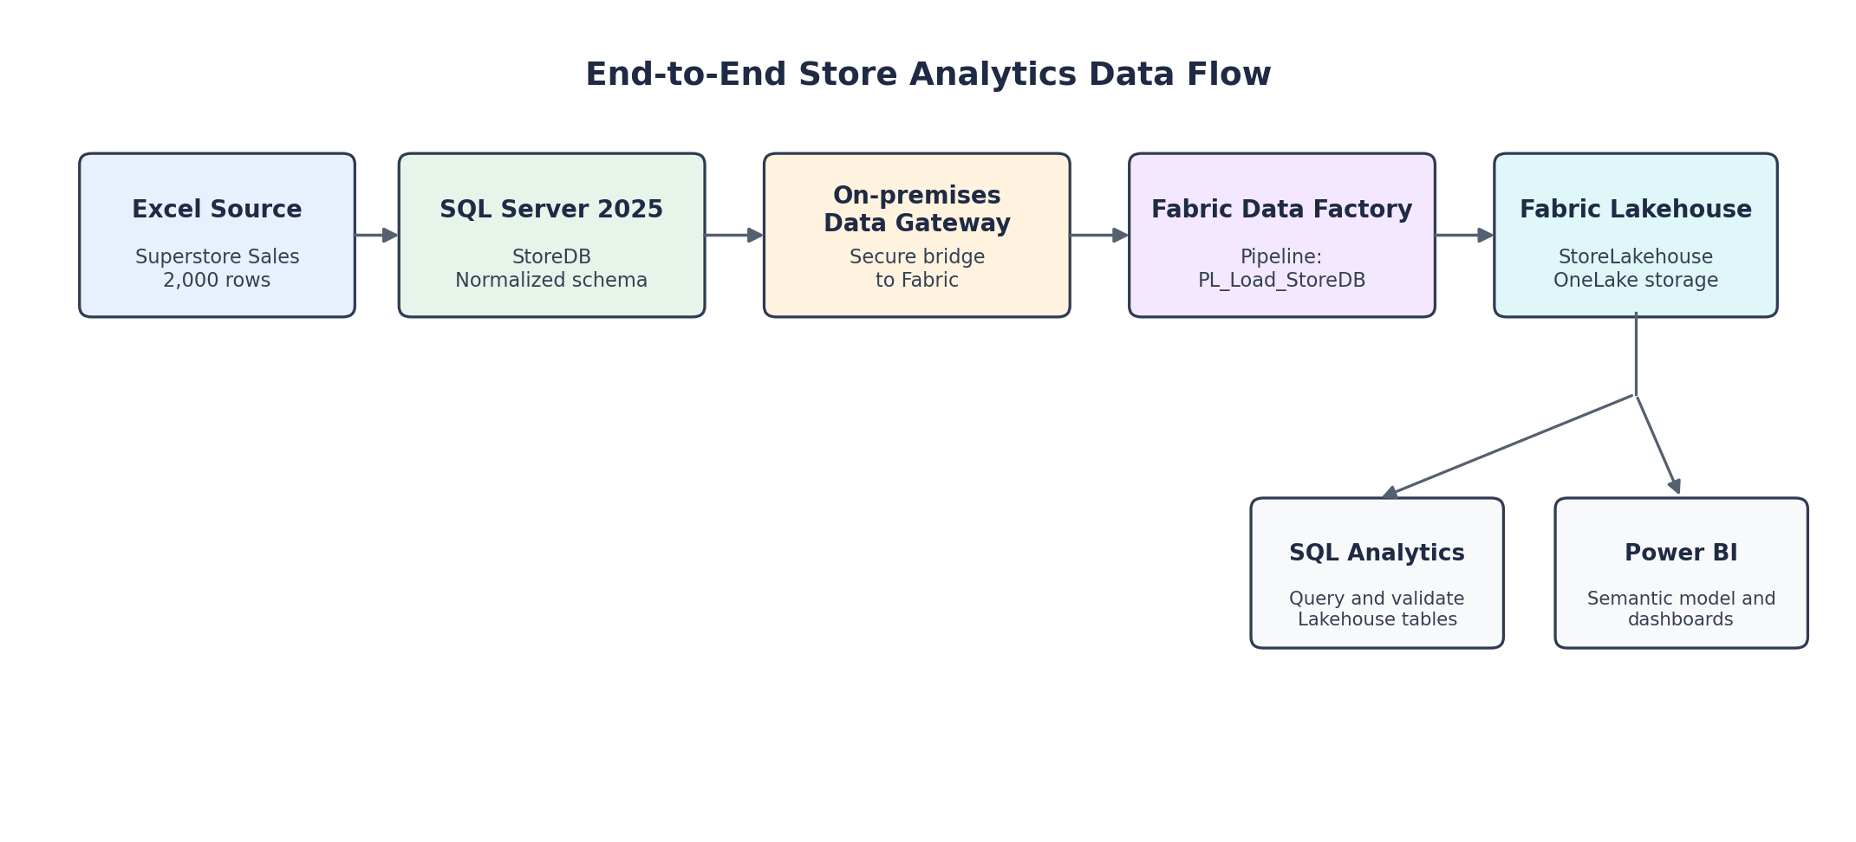

What is being done in Microsoft Fabric
Connect to local SQL Server: The On-premises Data Gateway allows Fabric to reach StoreDB on the local computer.
Use Data Factory: PL_Load_StoreDB will copy selected SQL Server tables into StoreLakehouse.
Load Lakehouse tables: The normalized StoreDB tables will be stored in Fabric for downstream analytics.
Validate and transform: The ingested data will be checked with SQL and prepared for analysis.
Build analytics: The Lakehouse will support SQL analysis and a later Power BI report.

Current status
- SQL Server, StoreDB and the gateway connection are working.
- Fabric can now see the StoreDB source tables.
- The next task is to configure the Copy Data activity and load dbo.Customers into StoreLakehouse as the first test.

Final outcome
The completed project will demonstrate a practical data pipeline from a local SQL Server database to Microsoft Fabric, including gateway connectivity, Data Factory ingestion, Lakehouse storage, SQL analytics and Power BI reporting.

Next steps
- Copy dbo.Customers into StoreLakehouse and verify the row count.
- Copy the remaining normalized tables and validate their schemas.
- Create SQL queries and analytics-ready summary tables/views in Fabric.
- Build a Power BI report using the Fabric data.
- Add screenshots, SQL scripts and notes to the GitHub repository as the project progresses.

